1. Install boards in arduino with custom boards: http://arduino.esp8266.com/stable/package_esp8266com_index.json

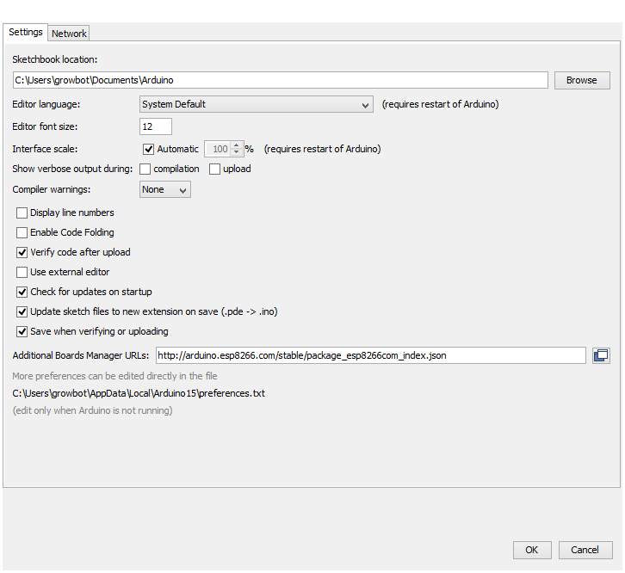

1. Then tools / boards / boards manager and install esp8266

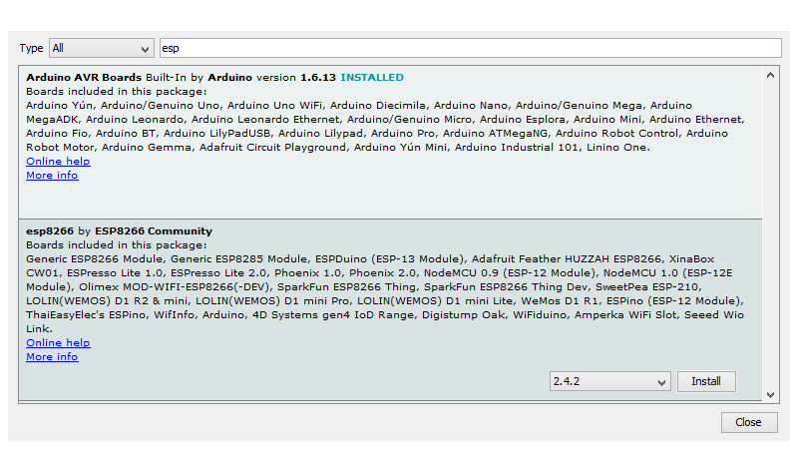

1. Install blynk libraries. Sketch / libraries / manager and search for blynk

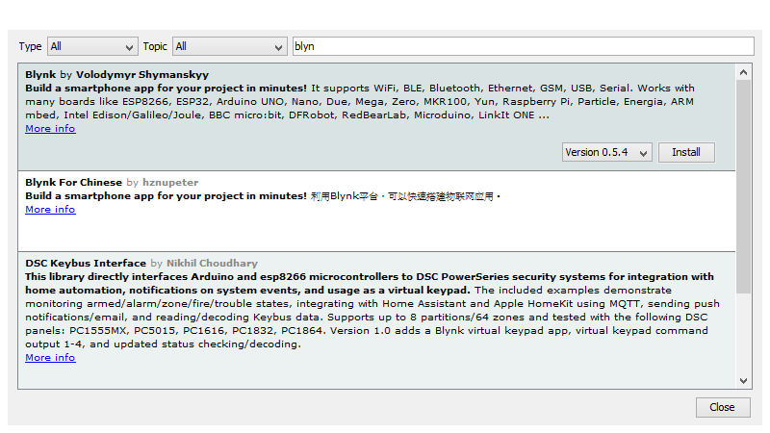

1. Copy examples from <https://examples.blynk.cc/>